Haunt My House

Puzzle Solver Manual

For 4 – 6 players

This manual is your holy grail for ghost hunting.

It tells you everything you need to know about ghosts and how to banish them.

Keep this with you at all times, it may save your life!

From the Hoppi Studio Team.

Contents

Introduction 4

Setup 4

How To Play 4

Blockout 4

Ghosts 5

Introduction 5

Puzzle Guide 5

Candle puzzle 5

Lever puzzle 11

Symbol puzzle 12

# Introduction

## Setup

One player is given the VR headset to wear.

Two players each take one of the VR controllers.

The remaining players will act as information handlers to help the VR players complete actions and win the game.

## How To Play

To win the game, you will need to work with the person with the headset and the people holding the controllers to solve all the puzzles before the time runs out and ghosts kill you!

There are a total of three puzzles to solve to banish all ghosts – a symbol puzzle, a lever puzzle and a candle puzzle.

You can see your life and the progress of each puzzle on the game screen.

## Blockout

Before playing the game, you will need to blockout world objects inside the game world. Use the **Trigger** **button** on the **right** **controller** on three corners of an object to create a virtual object.

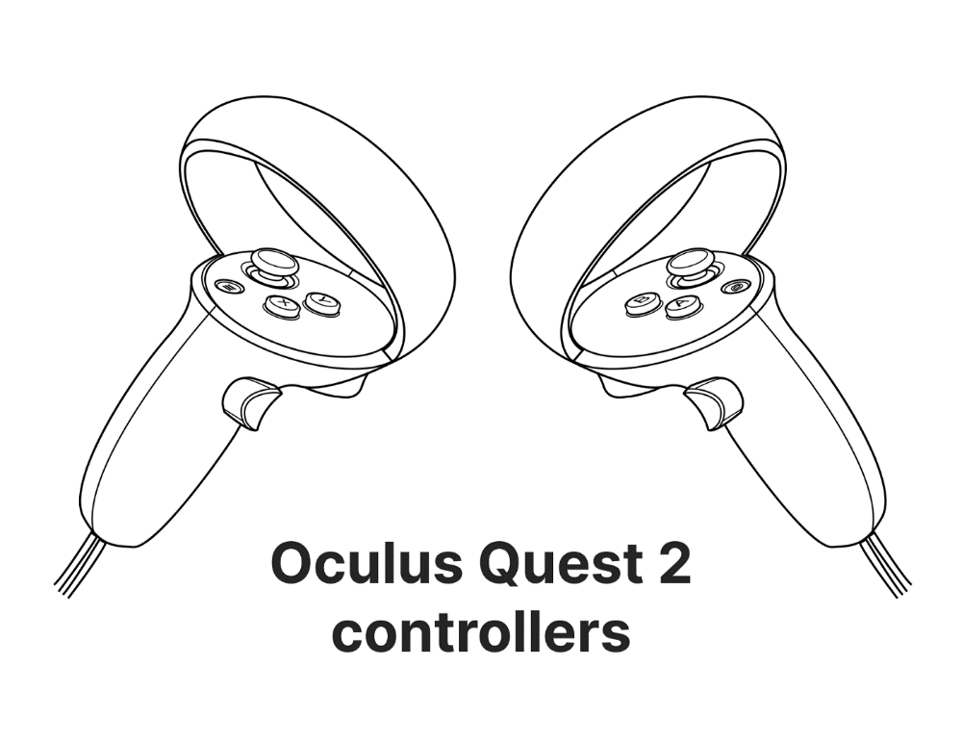

Menu selection

Object Blockout

Once you have finished blocking out the objects in the room, press the continue button to begin the game.

# Ghosts

## Introduction

Each ghost you encounter will be different and, as such, will require a different puzzle to be solved to banish it.

# Puzzle Guide

## Candle puzzle

**OVERVIEW**

In this puzzle the VR player is surrounded by 7 pedestals, each of which can hold one candle. Behind the player are two tables. One table holds three pots of coloured chemicals (flames), a matchbox, and a matchstick, whilst the other table holds a red button that can be pressed to spawn candles.

Each time this puzzle is loaded, one of three possible puzzle patterns is automatically selected. These different patterns provide variations in the shape symbols that will appear on pedestals, the candle flame colour required on each pedestal, as well as the flame mixing rules required for producing a new colour from the colours initially provided.

To complete the puzzle players must work together to place candles onto all of the correct pedestals to banish the ghost!

**HOW TO PLAY**

The table to right of the VR player holds the matchbox, matchstick, and a series of pots with different coloured flames. The player starts off with access to the colour’s orange (from striking the matchbox), green, blue, and white.

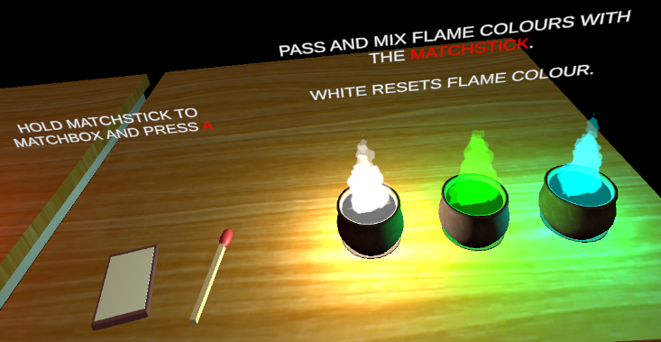

**OBJECT INTERACTION**

Grabbable objects comprise candles, the matchstick, and the matchbox. These can be picked up by holding down the trigger button. Releasing the trigger will drop the held object.

Light matchstick button



Grab candles/matchbox

**SPAWNING CANDLES**

On the table to the left lies a red button. Pressing this button will cause a candle to spawn to the right of it.

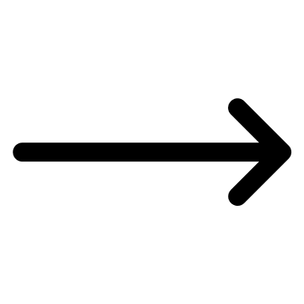

**IGNITING FLAMMABLE OBJECTS**

By bringing the matchstick towards the matchbox and pressing the A button, the matchstick can be lit with an orange flame colour.

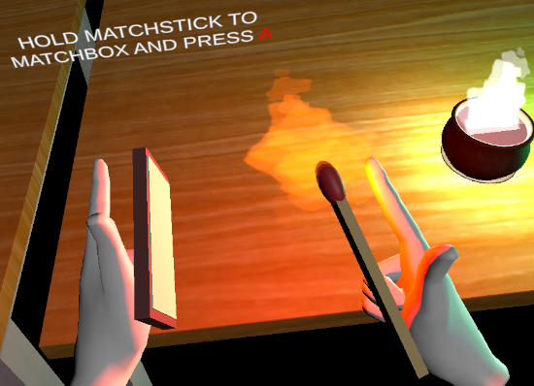

Candles can be ignited when the matchstick is brought in contact with it.

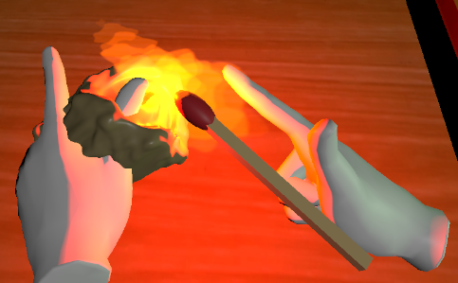

Unlit candles may also be set alight by bringing an already lit candle in contact with it.

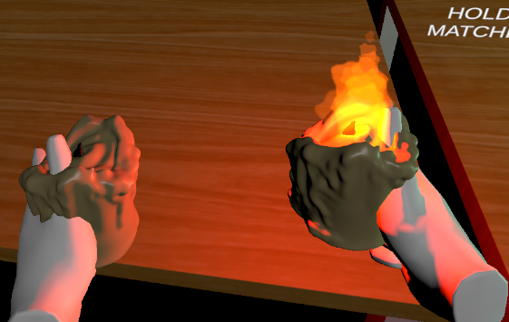

**COLOUR MIXING**

Flame colours can be passed using the matchstick. The matchstick flame colour can be reset at any time by passing the matchstick flame through a white flame. Mixing with any other colour after doing this will turn the flame colour to the newly collided colour. I.e., White => Green.

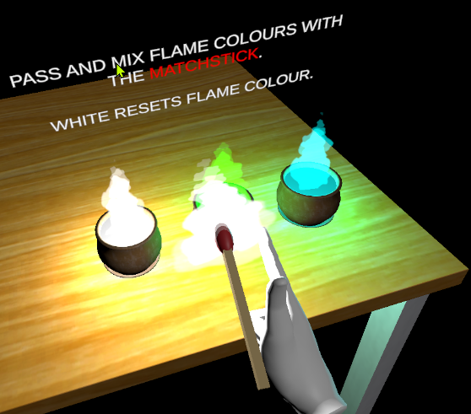

By combining the correct colours, a new colour can be produced. In the example below, mixing an orange flame with a blue flame produces a red flame.

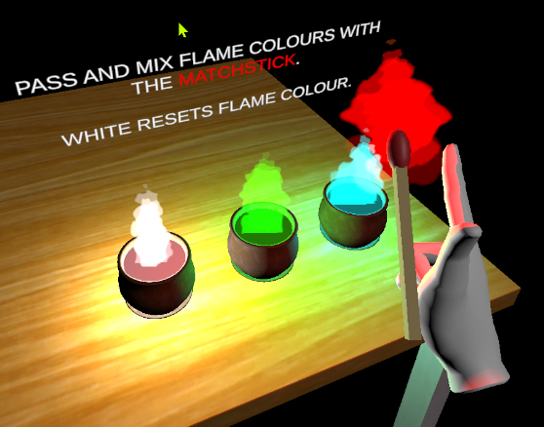

Attempting to mix a flame colour with another flame colour that doesn’t match an existing colour mixing rule will result in the matchstick flame being extinguished.

**CANDLE PLACEMENT**

To place a candle on a pedestal simply grab and drop the candle over the base of the pedestals candle holder. The candle will glow green or red whilst in the player’s hand when hovered over the candle holder, depending on whether the candle is allowed to be placed there.

Once a candle has been successfully placed, the pedestal’s flame symbol will glow in the colour of its placed candle’s flame.

**PUZZLE PATTERNS**

Three of the following five shapes will appear on random pedestals upon starting the game. These will help indicate which pattern is currently in play. The colour of each shape does not change.

**4**

**1** matchstick button

**2**

**5**

**6**

**7**

**3**

|  |  |  |  |  |
| --- | --- | --- | --- | --- |
| **Colour Mixing Rules** | | | | |
| **Fire with solid fill** | **+** | **Fire with solid fill** | **=** | **Fire with solid fill** |
| **Fire with solid fill** | **+** | **Fire with solid fill** | **=** | **Fire with solid fill** |
| **Fire with solid fill** | **+** | **Fire with solid fill** | **=** | **Fire with solid fill** |
| **Fire with solid fill** | **+** | **Fire with solid fill** | **=** | **Fire with solid fill** |
| **Fire with solid fill** | **+** | **Fire with solid fill** | **=** | **Fire with solid fill** |

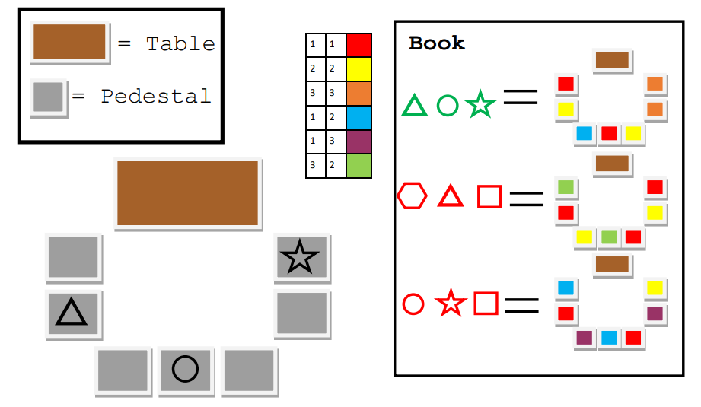

= matchstick button

**1** matchstick button

**2**

**3**

**4**

**5**

**6**

**7**

Pattern 1 matchstick button

|  |  |  |  |  |
| --- | --- | --- | --- | --- |
| **Colour Mixing Rules** | | | | |
| **Fire with solid fill** | **+** | **Fire with solid fill** | **=** | **Fire with solid fill** |
| **Fire with solid fill** | **+** | **Fire with solid fill** | **=** | **Fire with solid fill** |
| **Fire with solid fill** | **+** | **Fire with solid fill** | **=** | **Fire with solid fill** |
| **Fire with solid fill** | **+** | **Fire with solid fill** | **=** | **Fire with solid fill** |
| **Fire with solid fill** | **+** | **Fire with solid fill** | **=** | **Fire with solid fill** |

= matchstick button

**2**

**6**

**7**

**4**

**3**

**1** matchstick button

**5**

Pattern 2 matchstick button

|  |  |  |  |  |
| --- | --- | --- | --- | --- |
| **Colour Mixing Rules** | | | | |
| **Fire with solid fill** | **+** | **Fire with solid fill** | **=** | **Fire with solid fill** |
| **Fire with solid fill** | **+** | **Fire with solid fill** | **=** | **Fire with solid fill** |
| **Fire with solid fill** | **+** | **Fire with solid fill** | **=** | **Fire with solid fill** |
| **Fire with solid fill** | **+** | **Fire with solid fill** | **=** | **Fire with solid fill** |
| **Fire with solid fill** | **+** | **Fire with solid fill** | **=** | **Fire with solid fill** |

= matchstick button

**3**

**4**

**5**

**6**

**7**

**1** matchstick button

**2**

Pattern 3 matchstick button

Depending on which pattern is in play, each pedestal will require different coloured candles to be placed on it. Furthermore, a different colour mixing ruleset will be introduced for each pattern. The VR player must communicate to the other players which three shape symbols they can see engraved on the pedestals. Using this information, the other players must inform the VR player which pedestals require which coloured candle; as well as telling them how to produce specific flame colours.

## Lever puzzle

The second puzzle has five levers which need to be set in their correct state to pass through the puzzle. The solutions are the following:

1.

2.

3.

## Symbol puzzle

The last puzzle is a symbol puzzle where talismans need to be put on pedestals to match the correct order. The solutions are below:

1. 2. 3. 4. 5. 6.

1. 2. 3. 4. 5. 6.

1. 2. 3. 4. 5. 6.